PRODUCT NAME | Male Huanarpo Powder | 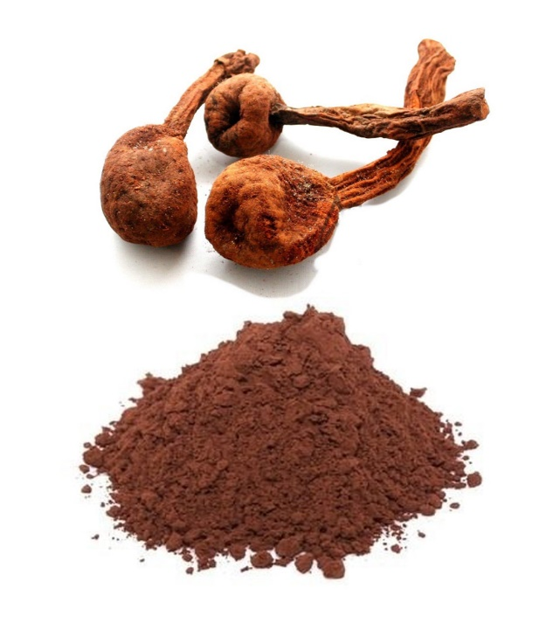
SCIENTIFIC NAME | Jatropha macrantha
H.S. CODE | 12.11.90
COUNTRY OF ORIGIN | Peru
GENERAL DESCRIPTION | The male Huanarpo is a medium-sized tree or shrub native to Peru. It contains sapogenins, steroids, flavonoids, essential oils and alkaloids and a large amount of proanthocyanidins. Proanthocyanidins are compounds, which occur naturally in several plants, with anti-inflammatory and anti-arthritic activities.  Male Huanarpo powder is made from trunk and bark of Male Huanarpo which are processed into a fine powder. 100% pure and natural, does not contain preservatives, artificial colors or flavors.
INGREDIENTS | 100% Huanarpo
PHYSICO – CHEMICAL  CHARACTERISTICS | Color  Odour  Taste  Texture  Appearance  Humidity  Foreign matters | Brown  Characteristic  Characteristic  Characteristic  Powder  12% max  Absence
NUTRITION FACTS  (100 g) | Energy (kcal)  Water  Proteins (g)  Lipids (g)  Carbohydrates (g)  Fiber (g)  Iron (g) | 328  9.3  4  2.4  25.0  2.3  4.6
MICROBIOLOGICAL  CHARACTERISTICS | MICROBIAL AGENT | LIMITS
 | Aerobic Mesophilic  Molds  Coliforms  E.coli  Samonella sp  Pesticides | <10000 ufc/g  <100 ufc  <10 ufc/g  <10 ufc/g  Absence/25 gr  Absence
BENEFITS | - It helps to reduce stress.  - It is considered a potent male aphrodisiac, sexual stimulant.  - Increases the immunity of the body.  - Mucous tonic (genitourinary, gastrointestinal and renal mucous membrane)  - Against skin ulcers  - Antidiabetic  - Antiasthmatic
USE  confirmed | It is recommended to consume an average of 2 to 3 g per day of Male Huanarpo powder in decoction.  There is not enough scientific evidence to ensure its use in pregnant women or children.
PACKING MATERIAL | Bags: Quantity of choice.
SHELF LIFE | 24 months after production date.
STORAGE | Indoor, ventilated, dry environment.
LABEL INFORMATION | Product name, net weight, manufacturer name and address, production and expiration date and country of origin. According to customer requirement.

